**Contents**

1.Machine learning

* + Types of Machine Learning Algorithms
  + Step to involve in ml model

2.Deep learning

* + Types of Deep learning

3.Git hub

* What is git hub
* Commands used to push the code

4.Postman

* What postman?
* Uses of postman

5. Docker

* + Why docker ?
  + Step to involve the to deploy the docker image in docker container.

**MACHINE LEARNING**

**Introduction to machine learning:**

* Machine learning is the idea that there are generic algorithms that can tell you something interesting about a set of data without you having to write any custom code specific to the problem.
* **Arthur Samuel defined Machine Learning in 1959**
* Machine Learning is a subset of Artificial Intelligence.

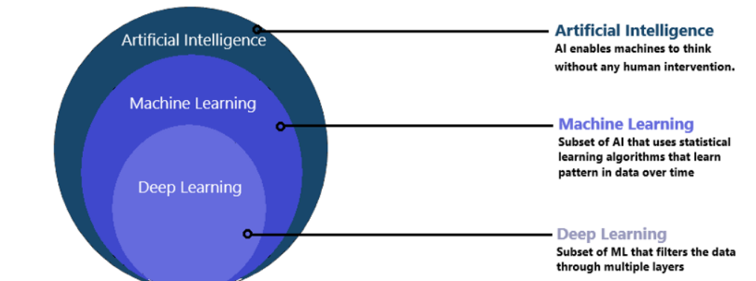

**Types of Machine Learning Algorithms:**

Based on **X** (Input Variables) and **Y** (Output Variables) machine learning algorithms are classified in three categories : 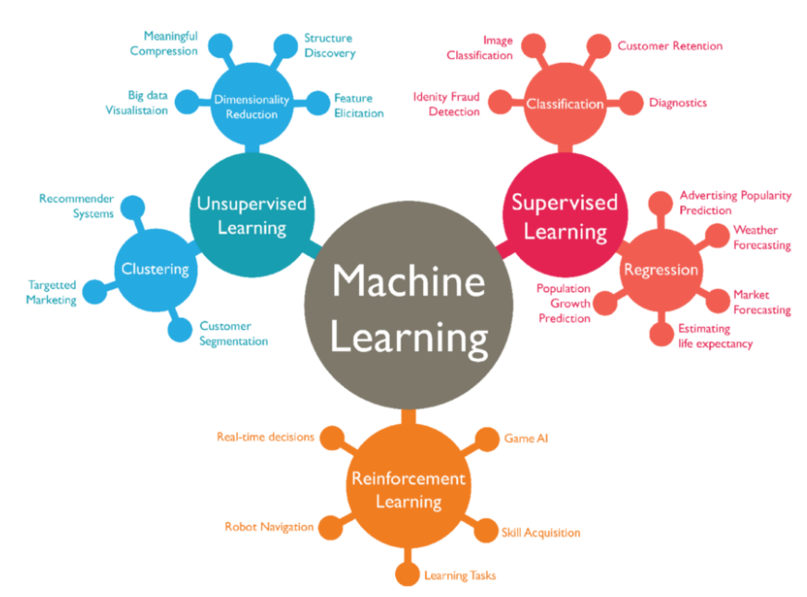

**Supervised Learning: The main goal of the supervised learning technique is to map the input variable(x) with the output variable(y).**

**Supervised Learning: Again two main types:**

* **Classification:** A classification algorithm aims to sort inputs into a given number of categories or classes, based on the labeled data it was trained on. Classification algorithms can be used for binary classifications such as filtering email into spam or non-spam and categorizing customer feedback as positive or negative. Feature recognition, such as recognizing handwritten letters and numbers or classifying drugs into many different categories, is another classification problem solved by supervised learning.
* **Regression:** Regression algorithms are different, as they expect the model to produce a numerical relationship between the input and output data. Examples of regression models include predicting real estate prices based on zip code, or predicting click rates in online ads in relation to time of day, or determining how much customers would be willing to pay for a certain product based on their age.

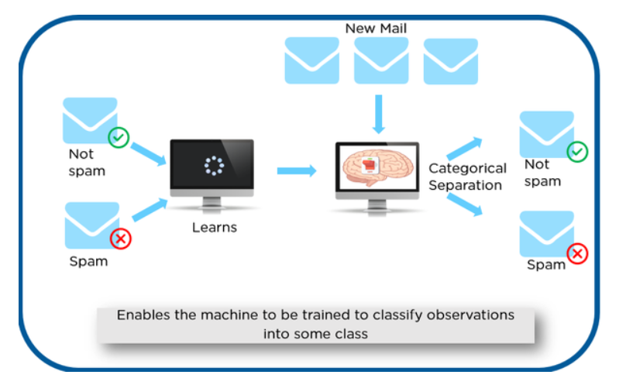

* **Unsupervised Learning: The main aim of the unsupervised learning algorithm is to group or categories the unsorted dataset according to the similarities, patterns, and differences.**

**Unsupervised Learning: Again two main types:**

* **Clustering:** The clustering technique is used when we want to find the inherent groups from the data. It is a way to group the objects into a cluster such that the objects with the most similarities remain in one group and have fewer or no similarities with the objects of other groups.
* **Association:** Association rule learning is an unsupervised learning technique, which finds interesting relations among variables within a large dataset.

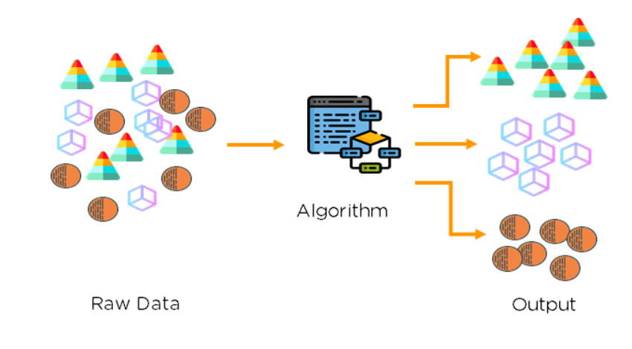

* **Reinforcement learning: Reinforcement learning works on a feedback-based process, in which an AI agent (A software component) automatically explore its surrounding by hitting & trail, taking action, learning from experiences, and improving its performance.**

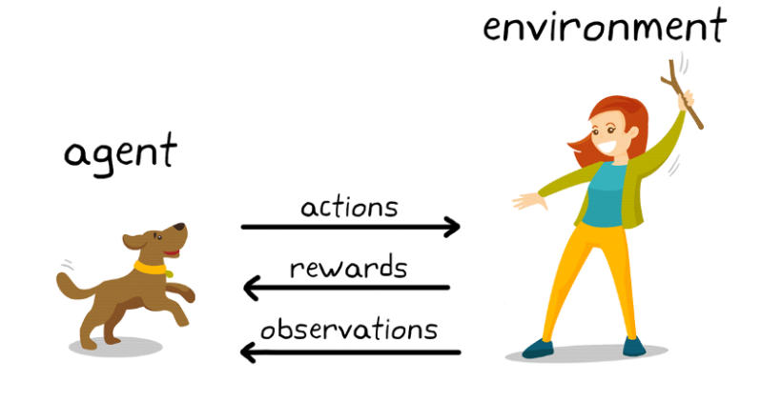

Machine Learning Algorithm takes input data and **“generates rules”** so that when an unknown input is **passed in it** we get predicted output.



Here,

* **Y is Output** (also called *Output Variable / Dependent Variable*)
* **X is Input** (also called *Input Variables / Input Vector / Independent Variable*)
* ***f*() is mapping function** (also called *Algorithm*)

Step to involve in ml model:

In simple term, Machine Learning means making prediction based on data.

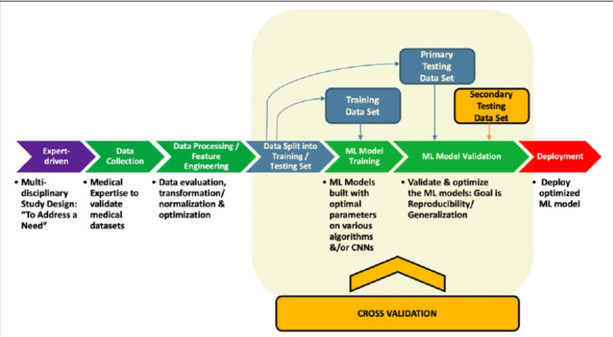**Data Collection:**

Identify various data sources such as Kaggle and collect the required dataset

**Data processing:**

In this step, we do an analysis of the data for missing values, duplicate data, invalid data using different analytical techniques. And also preprocessing the data for feature extractions, feature analysis, and data visualization.

**Data split:**

We use a dataset to train the model using various machine learning algorithms. Training a model is important so that it can understand the various patterns, rules, and features.

**Model Training:**

In this step, we check for the accuracy of our model by providing a test dataset to the trained model.

**Model Deployment:**

Model deployment means integrating a machine learning model into an existing production environment that takes input and returns output to make business decisions based on data. **Various technologies that you can:**

1.Docker

2.Kubernetes

3.AWS,AZURE,GCP

**2.DEEP LEARNING**

Deep learning is a subset of [machine learning](https://www.ibm.com/cloud/learn/machine-learning), which is essentially a neural network with three or more layers. These neural networks attempt to simulate the behavior of the human brain—albeit far from matching its ability—allowing it to “learn” from large amounts of data

**Types of neural networks that form the basis for most pre-trained models in deep learning**:

* Artificial Neural Networks (ANN)
* Convolution Neural Networks (CNN)
* Recurrent Neural Networks (RNN)

**Artificial Neural Networks (ANN):**

Neural networks, also known as artificial neural networks (ANNs) or simulated neural networks (SNNs), are a subset of [machine learning](https://www.ibm.com/cloud/learn/machine-learning) and are at the heart of [deep learning](https://www.ibm.com/cloud/learn/deep-learning) algorithms. Their name and structure are inspired by the human brain, mimicking the way that biological neurons signal to one another.

Artificial neural networks (ANNs) are comprised of a node layers, containing an input layer, one or more hidden layers, and an output layer. Each node, or artificial neuron, connects to another and has an associated weight and threshold. If the output of any individual node is above the specified threshold value, that node is activated, sending data to the next layer of the network. Otherwise, no data is passed along to the next layer of the network.

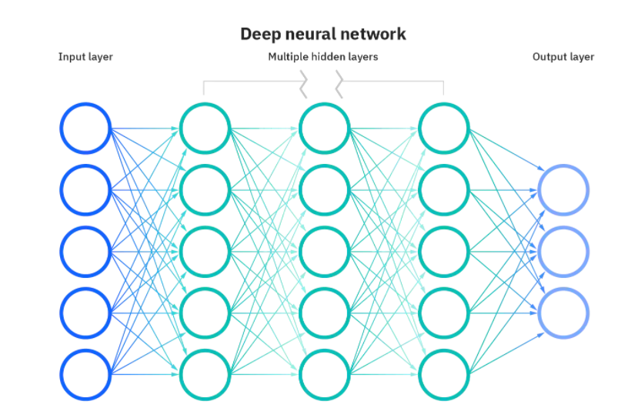

**Convolution Neural Networks (CNN):**

The convolutional layer is the first layer of a convolutional network. While convolutional layers can be followed by additional convolutional layers or pooling layers, the fully-connected layer is the final layer. With each layer, the CNN increases in its complexity, identifying greater portions of the image. Earlier layers focus on simple features, such as colors and edges. As the image data progresses through the layers of the CNN, it starts to recognize larger elements or shapes of the object until it finally identifies the intended object.

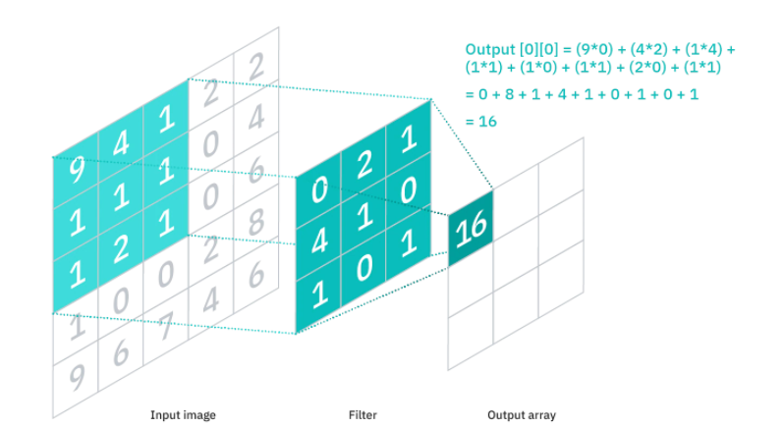

**Recurrent Neural Networks (RNN):**

A recurrent neural network (RNN) is a type of artificial neural network which uses sequential data or time series data. These deep learning algorithms are commonly used for ordinal or temporal problems, such as language translation, natural language processing (nlp), speech recognition, and image captioning; they are incorporated into popular applications such as Siri, voice search, and Google Translate. Like feedforward and convolutional neural networks (CNNs), recurrent neural networks utilize training data to learn.

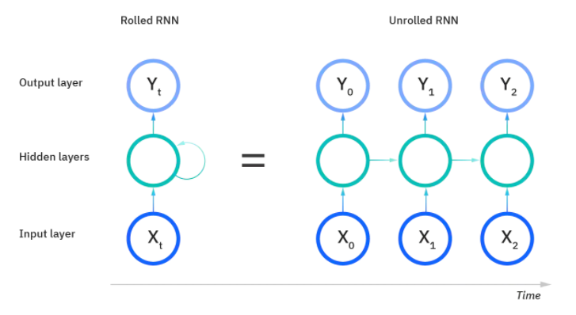

**GITHUB**

Git hub:

* GitHub is a code hosting platform for version control and collaboration.
* It lets you and others work together on projects from anywhere.

In this quick start guide, you will:

* Create and use a repository
* Start and manage a new branch
* Make changes to a file and push them to GitHub as commits
* Open and merge a pull request.

Commands:

**Username:**$ git config - -global user.name <Name>​

**E-Mail:** $ git config - -global user.email <mail id>​

**Alias:** $ git config - -global alias <alias-name> <git command>​

**Editor:** $ git config - -system core.editor <.exe file path>​

**Edit** **Global file:** $ git config - -global - -edit​

**List all:**$ git config - -global - -list​

**To initiate git-** $ git init ​

**Add files to index or staging area-** $ git add <filename> or $ git add .​

**Git files Status-** $ git status​

**Commit files to local repo-** $ git commit –m '<commit info>'​

**To add remote repo-** $ git remote add <unique name> "URL Link"​

**To get data from Remote repo-** $ git pull <unique name> <branch name>​

**To send data to Remote repo-** $ git push <unique name> <branch name>​

​

**To add and commit at the same time-** $ git commit –am '<commit info>'​

**To add empty commit-** $ git commit –a - -allow-empty-message –m ‘ ‘ ​

**To check available branches in local repo-** ​

$ git branch or $ git branch -l​

**To create a new branch-** $ git branch <name>​

**To delete a branch-** $ git branch –d <name>​

**To go to a specific branch-** $ git checkout <branch name>​

**To create new and go to that branch directly-** ​

$ git checkout –b <branch name>​

**To get all branches local and remote-** $ git branch -a​

**To delete a branch in Remote repo-** ​

$ git push origin --delete <branch name>​

**To merge branches:** $ git merge <branch name>

**Postman**

Postman is an API platform for building and using APIs. Postman simplifies each step of the API lifecycle and streamlines collaboration so you can create better APIs—faster.

Uses:

Postman is an application used for API testing It is an HTTP client that tests HTTP requests, utilizing a graphical user interface, through which we obtain different types of responses that need to be subsequently validated. 

**Docker**

**why docker?**

* [Docker](https://www.blogger.com/blog/post/edit/1265922879384371667/1205714981232207974) is a containerization service that allows for websites, APIs, databases, and, in our case, data science models to be deployed anywhere
* Docker is lightweight and doesn't take up as much memory as other methods and has a faster startup time.
* Docker containers are a popular way to deploy custom ML environments that run consistently in multiple environments

**Step 1:**

* Flask code in vs code .Run and check in local server.
* output

[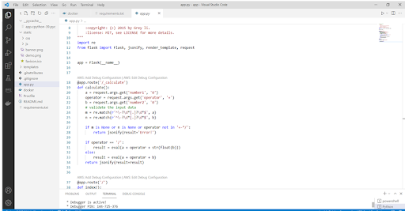](https://www.blogger.com/blog/post/edit/1265922879384371667/1205714981232207974)

[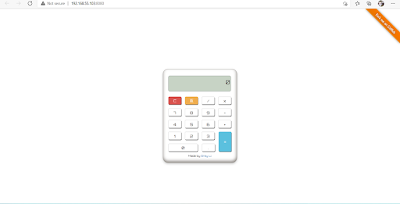](https://www.blogger.com/blog/post/edit/1265922879384371667/1205714981232207974)

step 2:

* After executing flask code
* we need go docker code and then execute it .

[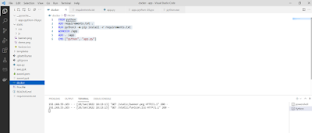](https://www.blogger.com/blog/post/edit/1265922879384371667/1205714981232207974)

Step 3:

* open and install docker in laptop.
* click to login with some credentials

[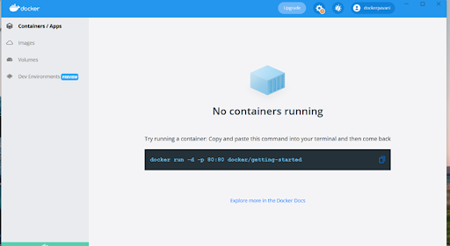](https://www.blogger.com/blog/post/edit/1265922879384371667/1205714981232207974)

* Take that url and paste it over in terminal and then execute it .

[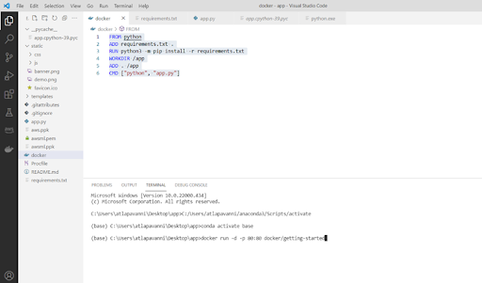](https://www.blogger.com/blog/post/edit/1265922879384371667/1205714981232207974)

* Then go to vs code and click docker .
* Right click and select image bulid,it will build to the container.
* As shown in below.

[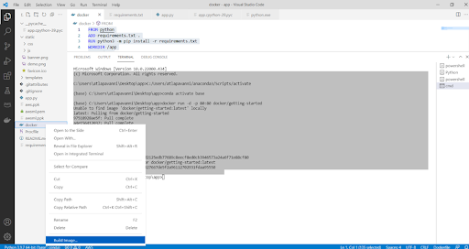](https://www.blogger.com/blog/post/edit/1265922879384371667/1205714981232207974)

[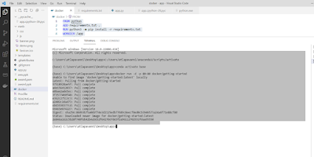](https://www.blogger.com/blog/post/edit/1265922879384371667/1205714981232207974)

* loaded in the container.

[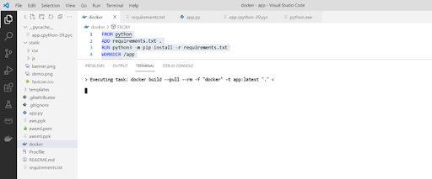](https://www.blogger.com/blog/post/edit/1265922879384371667/1205714981232207974)

[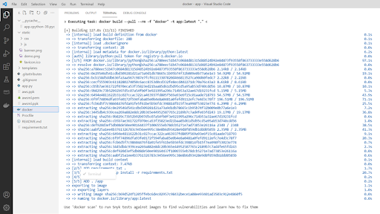](https://www.blogger.com/blog/post/edit/1265922879384371667/1205714981232207974)

**Step 3:**

* We need to check whether the image loaded or not in the container.
* firstly open the docker and then go to --> to image .check.

[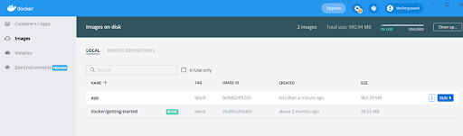](https://www.blogger.com/blog/post/edit/1265922879384371667/1205714981232207974)

* final image got push in the container.

[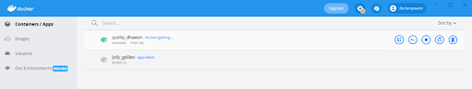](https://www.blogger.com/blog/post/edit/1265922879384371667/1205714981232207974)

Step 4:

I. Create AWS account  and login

* our goal is to deploy flask application to docker in  AWS Cloud.
* For this, we need to have an AWS account.
* After creating the account you need to go to AWS Management Console and need to sign in to AWS by using the account that you have just created.

[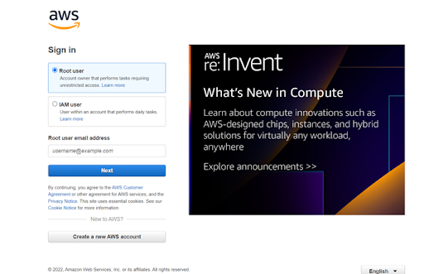](https://www.blogger.com/blog/post/edit/1265922879384371667/1205714981232207974)

II. Create EC2 instance

* AWS Management Console and search for EC2 and need to click on running instances.
* Click on Launch Instance to create the new EC2 instance.

[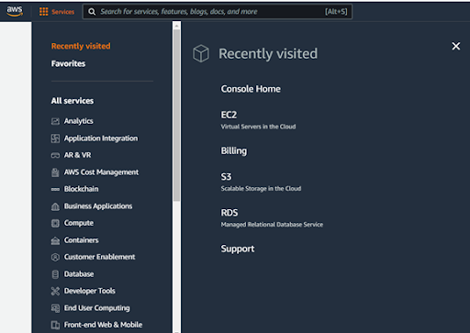](https://www.blogger.com/blog/post/edit/1265922879384371667/1205714981232207974)

* Go to EC2 dashboard launch instance and then create the instance

[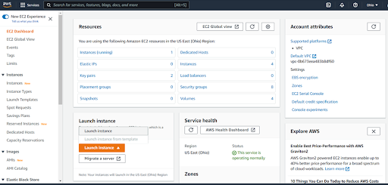](https://www.blogger.com/blog/post/edit/1265922879384371667/1205714981232207974)

III. Choose an Amazon Machine Image (AMI)

* We need to choose AMI which means choosing an OS for the server.
* In this case, we can choose the UBUNTU 20.04which is a free tier and proceed next.

[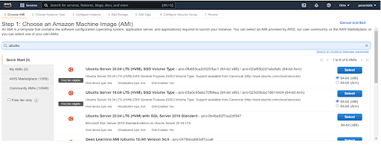](https://www.blogger.com/blog/post/edit/1265922879384371667/1205714981232207974)

IV. Choose Instance Type

* Now we need to choose instance type for our server.
* In this case, we can go with a free tier instance.

[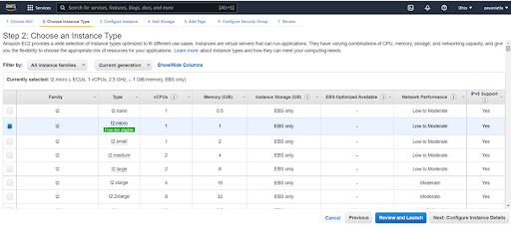](https://www.blogger.com/blog/post/edit/1265922879384371667/1205714981232207974)

V. Creating a Private Key Pair

* Once you followed with the above steps you will be able to click on the launch button in “Review Instance Launch”. You will be getting a pop-up for choosing a private key pair.
* Let’s click on create a new private key pair and choose a keypair name.
* Now we need to click on the download key pair button to download it.

[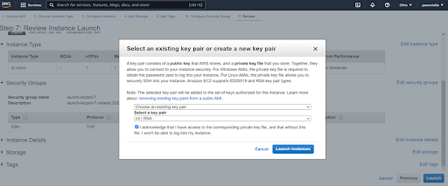](https://www.blogger.com/blog/post/edit/1265922879384371667/1205714981232207974)

* Done with create instance launching.

[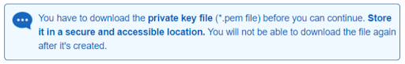](https://www.blogger.com/blog/post/edit/1265922879384371667/1205714981232207974)

we can be able to create an EC2 Instance. Now we need to go to view instances where you could be able to find the instance you have created.

[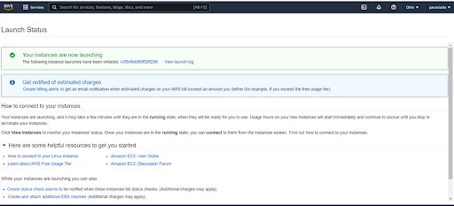](https://www.blogger.com/blog/post/edit/1265922879384371667/1205714981232207974)

[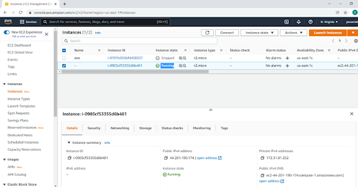](https://www.blogger.com/blog/post/edit/1265922879384371667/1205714981232207974)

Step 5:

* Download putty, putty gen
* [https://www.putty.org/](https://www.blogger.com/blog/post/edit/1265922879384371667/1205714981232207974)

[Putty](https://www.blogger.com/blog/post/edit/1265922879384371667/1205714981232207974):- It is a free and open-source terminal emulator, serial console, and network file transfer application. It supports several network protocols, including SCP, SSH, Telnet, rlogin, and raw socket connection. It can also connect to a serial port.

[[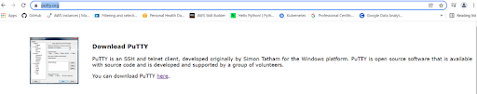](https://www.blogger.com/blog/post/edit/1265922879384371667/1205714981232207974)](https://www.blogger.com/blog/post/edit/1265922879384371667/1205714981232207974)

* ·        convert a private key from PPM format which you have downloaded previously to PPK format using PuttyGen.
* ·        Firstly open the  putty  and load that to pem file paste and its will automatically connected   into ppk file

[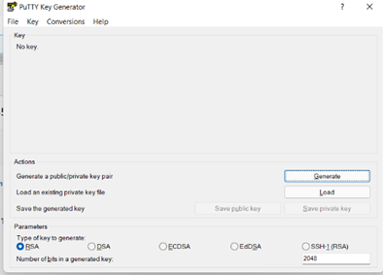](https://www.blogger.com/blog/post/edit/1265922879384371667/1205714981232207974)

[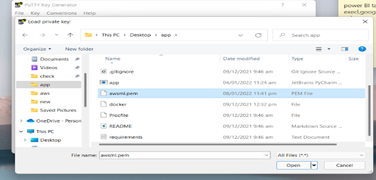](https://www.blogger.com/blog/post/edit/1265922879384371667/1205714981232207974)

Step 6:

* Open aws ec2 instance  copy public ipv4 DNS link.

[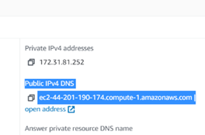](https://www.blogger.com/blog/post/edit/1265922879384371667/1205714981232207974)

* Open putty gen paste public ipv4 DNS  in host name.

[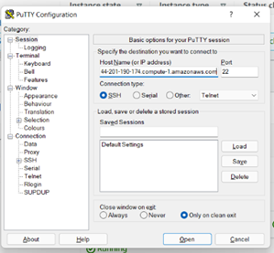](https://www.blogger.com/blog/post/edit/1265922879384371667/1205714981232207974)

* click the advanced filter and select ssh then click authentication
* search form ppk file and then  paste the link.
* Now click on advanced options and go to “Authentication” and insert the created private key in PPK format
* save it finally login it will connect with serve
* [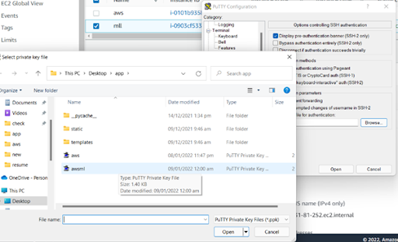](https://www.blogger.com/blog/post/edit/1265922879384371667/1205714981232207974)
* Some command used in ubuntu to execute the aws server

[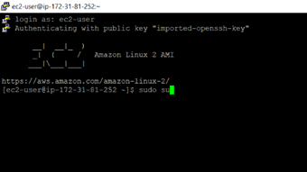](https://www.blogger.com/blog/post/edit/1265922879384371667/1205714981232207974)

sudo-apt update

[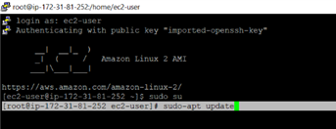](https://www.blogger.com/blog/post/edit/1265922879384371667/1205714981232207974)

[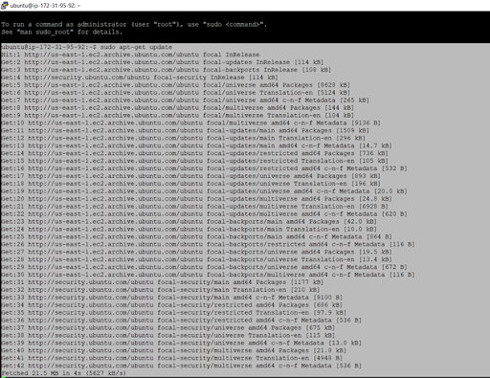](https://www.blogger.com/blog/post/edit/1265922879384371667/1205714981232207974)

[](https://www.blogger.com/blog/post/edit/1265922879384371667/1205714981232207974)

sudo apt install docker.io

[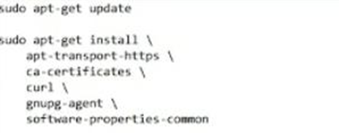](https://www.blogger.com/blog/post/edit/1265922879384371667/1205714981232207974)

[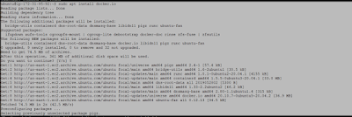](https://www.blogger.com/blog/post/edit/1265922879384371667/1205714981232207974)

* we need to give docker login credentials.

[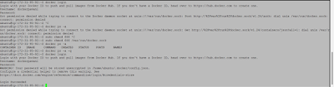](https://www.blogger.com/blog/post/edit/1265922879384371667/1205714981232207974)

[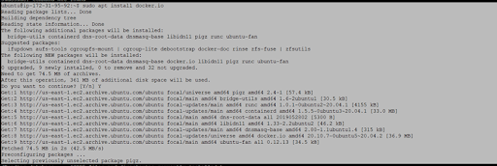](https://www.blogger.com/blog/post/edit/1265922879384371667/1205714981232207974)

Step 7:

* open the docker hub whether image loading or not

[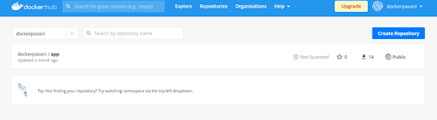](https://www.blogger.com/blog/post/edit/1265922879384371667/1205714981232207974)

[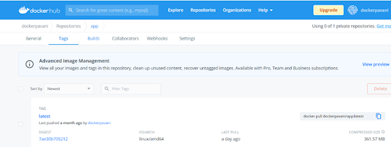](https://www.blogger.com/blog/post/edit/1265922879384371667/1205714981232207974)

* Using some commands we can push the image .As shown in image.

[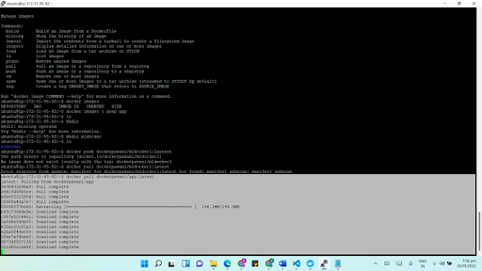](https://www.blogger.com/blog/post/edit/1265922879384371667/1205714981232207974)

[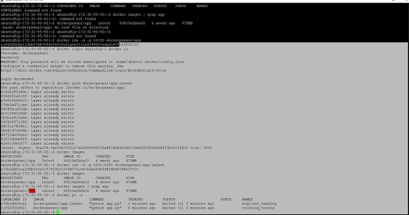](https://www.blogger.com/blog/post/edit/1265922879384371667/1205714981232207974)

we need to whether container id create or not. suppose container id got created image push  in the container.

[](https://www.blogger.com/blog/post/edit/1265922879384371667/1205714981232207974)